Based on: <https://datatofish.com/executable-pyinstaller/>

1. Install <https://www.python.org/downloads/>
2. Add path to evironment :

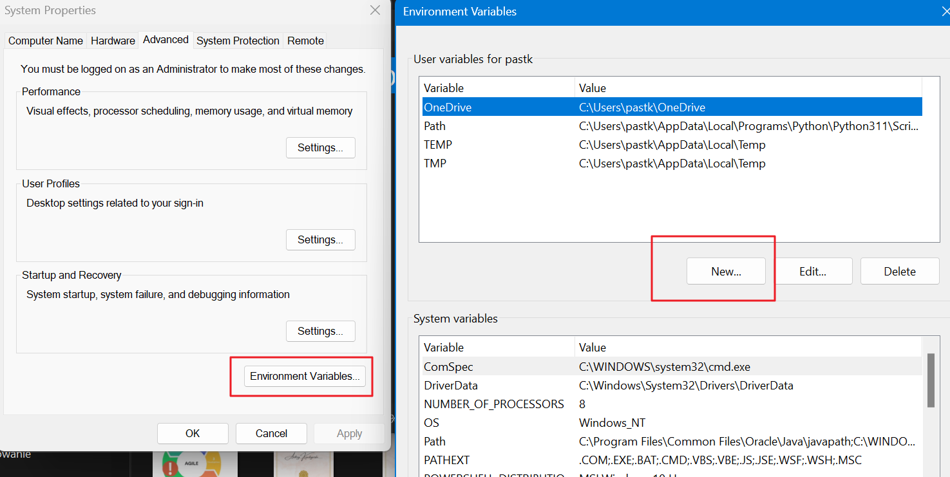

1. Go to your python folder (in mine case: C:\Users\username\AppData\Roaming\Microsoft\Windows\Start Menu\Programs\Python 3.11 )
2. Holding Shift open terminal
3. Run command: python –version



1. Run command pip install pyinstaller
2. Place your .py file inside the folder
3. Run command run pyinstaller --onefile main.py
4. Where main.py is your file name
5. You .exe file is in the dist folder